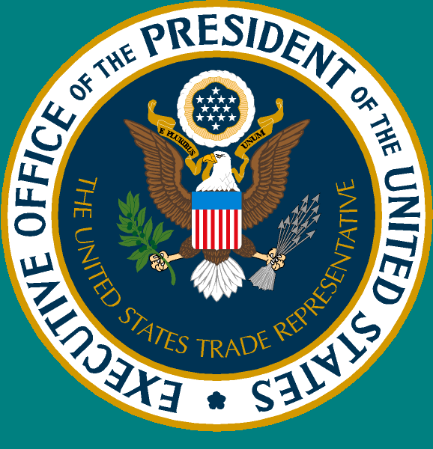 Trade and Investment
Office of the United States Trade Representative www.ustr.gov
Benefits of Trade – November 2006

Eight Misunderstandings About U.S. Investment Agreements and Trade

1. U.S. investment agreements do not encourage U.S. companies to move jobs overseas.

U.S. investment agreements remove discrimination of American investors in overseas markets and foreign investors in the United States. These agreements help increase economic efficiency and real incomes in the United States, and expand exports of goods and services abroad. As with other sources of economic activity, cross-border direct investment may entail job relocation. The loss of any job is painful, often disrupting families and communities. However, some points are worth bearing in mind:
- In the extremely dynamic U.S. economy, job creation exceeds job elimination. In general, the U.S. economy creates roughly 17 million new jobs per year, while eliminating roughly 15 million jobs.
Offshoring
Other reasons
- The attention paid to offshoring greatly exceeds its actual effect on job loss: for every 100 U.S. jobs eliminated, about two are due to import competition or offshoring (Fig. 1). New technologies, internal competition among domestic companies, change in demographic and consumer tastes, and other reasons account for the rest.
- Even for mass layoffs of more than 50 employees, less than three percent of the job losses are due to offshoring or import competition.
- Put another way, the U.S. economy creates about 54 new jobs for every job sent overseas.

So while some people do lose jobs—usually for reasons other than offshoring—it is more sensible to help them benefit from an expanding economy through training and other forms of support than resort to economic isolationism. After all, even though innovation eliminates many jobs, we don’t seek to limit innovation. Like trade and investment, it’s too important for overall economic growth.
2. Investing overseas does not reduce domestic investment and lower wages of American workers.

Engaging globally is good for the United States, its companies, and its workers.
- Each $10 of foreign capital investment is associated with $15 in additional U.S. domestic investment, and $10 in additional foreign employee compensation is associated with $18 in additional U.S. domestic employee compensation (Fig 2).
- U.S. companies with foreign affiliates pay their employees more than U.S. companies that do not (Fig. 4).
- Earnings from U.S. investment overseas were $245 billion in 2005, up 93 percent since 1999. In that period, half of these profits have been returned to the United States.

Investment agreements help create U.S. jobs not only by facilitating overseas expansion of U.S. companies, but also by attracting foreign investment into the United States. The growth-enhancing effects of foreign investment in the United States tend to exceed those of domestic investment because of greater technological spillover, providing a powerful spur to innovation and enhanced domestic investment.

- The 5.1 million Americans employed by affiliates of foreign companies make up less than 5% of the total U.S. workforce but account for more than 19% of all U.S. goods exports.
- In addition, employees of foreign-owned companies in the United States are paid, on average, 30% more than those of all U.S.-owned companies (Fig. 3).

3. Most U.S. foreign investment is not targeted at developing countries in order to use low-wage labor.

Most U.S. foreign direct investment (FDI) is in developed countries (Fig. 4). In 2004, 81 percent of U.S. outbound FDI stock was in high-income countries; less than 1 percent was in China. Foreign investors are more frequently motivated by access to major consumer markets than by low-wage labor. They also favor political and economic stability, the rule of law, and good governance. If foreign investors were primarily interested in finding low-wage labor, then the United States would not have the largest stock of FDI (by more than $800 billion in 2005), nor would FDI-supported jobs in the U.S. pay more than the average U.S. job, as shown in Fig. 3.
In recent years, developing countries have become relatively more important for flows of new FDI. Over the last three years, about one-third of global FDI flows went to developing countries. The competition to attract FDI from many companies puts pressure on developing countries to reduce corruption and improve their legal framework.

4. Investment agreements do not provide greater substantive rights to foreigners than to domestic investors in the United States.

Our agreements provide foreign investors with substantive rights that closely correspond to rights already available to any investor under US law – no more and no less. For example, the text of our agreements applicable to a dispute involving an expropriation claim would be one drawn directly from U.S. Supreme Court decisions.

More important, the agreements level the playing field for American investors in foreign markets where they often face an array of arbitrary, unfair, and corrupt government actions. U.S. investment agreements strengthen transparency, the rule of law, and basic property rights, helping to combat corruption in our trading partners. And when all else fails, they provide access to fair and independent international arbitration to settle disputes with the foreign government.

5. Investment agreements do not jeopardize the right of U.S. state and local governments to regulate in the public interest.

Nothing in these agreements interferes with a state or local government’s right to regulate for health, safety, consumer protection, or any other public welfare reason. An investor cannot enjoin regulatory action under our investment agreements, nor can arbitral tribunals.

The arbitration procedures of our investment agreements allow claims against the federal government, but not state or local governments. The United States has never lost a single arbitration under these agreements nor has it paid a single penny to settle a case. Moreover, if a panel ever did rule against the United States, it would have no authority to order the government to modify any law, regulation or practice.

6. Dispute settlement proceedings under these agreements, known as “investor-state arbitration,” are not secretive and non-transparent.

Investor-state arbitration hearings and documents are public. Amicus curiae submissions from the public are expressly allowed. Amicus submissions, transcripts of all hearings, tribunal decisions, and other documents related to investor-state arbitration under NAFTA are readily available online from the following State Department website: http://www.state.gov/s/l/c3439.htm

7. Foreign investors can not abuse the process by filing frivolous investor-state claims that threaten state and local regulations.

Our agreements include checks to ensure that investors cannot abuse the arbitration process, such as a special provision (based on US court rules) that allows tribunals to dismiss frivolous claims at an early stage of the proceedings or to award attorneys’ fees and costs as a deterrent to such claims.

8. Arbitral tribunals may not improperly interpret and apply the provisions of our international agreements.

Our agreements include special provisions that allow governments to review and comment on draft opinions before they are issued in final form. The agreements also expressly authorize the governments to issue interpretations of the agreement that are binding on tribunals.

Bernanke, Benjamin (2004). Trade and Jobs. http://www.federalreserve.gov/boarddocs/speeches/2004/20040330/default.htm.
Bernanke, Benjamin (2004). Trade and Jobs. http://www.federalreserve.gov/boarddocs/speeches/2004/20040330/default.htm.
Bureau of Labor Statistics (2006). Extended Mass Layoffs in 2005.
Bernanke, Benjamin (2004). Trade and Jobs. http://www.federalreserve.gov/boarddocs/speeches/2004/20040330/default.htm.
Desai, Mihir A., C. Fritz Foley, and James R. Hines Jr., (2005). Foreign Direct Investment and Domestic Economic Activity, NBER working paper 11717, October.
Bureau of Economic Analysis (July, 2005). Survey of Current Business: U.S. Multinational Companies, and “Insourcing Jobs,” House of Representatives Joint Economic Committee, 2004
Bureau of Economic Analysis (2006). U.S. International Transactions Accounts Data http://www.bea.gov/bea/international/bp_web/simple.cfm?anon=71&table_id=18&area_id=1
OECD, 1998, Open Markets Matter: The Benefits of Trade and Investment Liberalisation
Bureau of Economic Analysis (August, 2006) “U.S. Affiliates of Foreign Companies.”
House of Representatives Joint Economic Committee (2004). “Insourcing Jobs.”
U.S. International Trade Commission, 2006, Trends in U.S. Inbound and Outbound Direct Investment

